**Sather Tower Data Collection 2020-10-08**

Project Title:

Sensing of Sather Tower to promote STEM to URM High School students and support the PREP and T-PREP programs

Process I :

Instrumentation of Sather Tower with fiber optic strain sensing cables and accelerometers

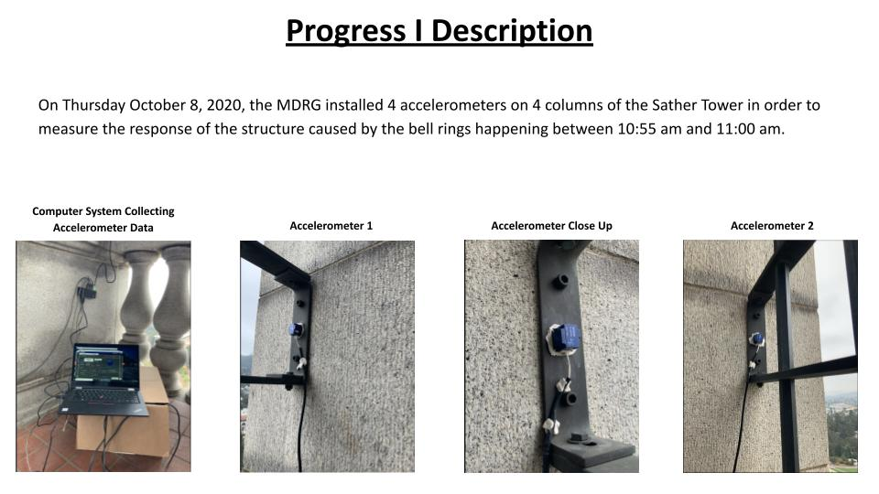



1. Acceleration Directions and serial numbers

Accelerometer 1 (North-West) | 1403

* X : Pointing out of plane
* Y : Pointing down | SW direction
* Z : Pointing right | NE direction

Accelerometer 2 (South-West) | 1399

* X : Pointing out of plane
* Y : Pointing right | SE direction
* Z : Pointing up | NW direction

Accelerometer 3 (South-East) | 0600

* X : Pointing out of plane
* Y : Pointing right | SE direction
* Z : Pointing up | NE direction

Accelerometer 4 (North-East) | 1402

* X : Pointing out of plane
* Y : Pointing up | NE direction
* Z : Pointing left | NW direction

1. Google Earth Orientation

|  |
| --- |
| IMG_E5A87654E54E-1.jpeg |